|  |  |
| --- | --- |
| Ex. No.:13 | **State Feedback and State Observer Design and Evaluation of Closed Loop Performance** |
| Date: |

**Aim**

To design State feedback and state observer model and to evaluate closed loop performance of DC motor.

**Introduction**

State feedback control systems open up a different landscape to control system design for complex systems that have a higher order or have many input and output variables. In control theory, a state observer or state estimator is a system that provides an estimate of the internal state of a given real system, from measurements of the input and output of the real system. It is typically computer-implemented, and provides the basis of many practical applications.

Knowing the system state is necessary to solve many control theory problems; for example, stabilizing a system using state feedback. In most practical cases, the physical state of the system cannot be determined by direct observation. Instead, indirect effects of the internal state are observed by way of the system outputs.. By choosing a set of desired closed‐loop eigenvalues, a state feedback controller is designed

**Procedure**

Step1: Calculate the state space model for the given DC motor

Step2: Check for controllability and observability

Step3: Build the state feedback and observer model in simscape using the calculated state variables

Step4: Simulate and observe the results.

**Matlab Circuit**

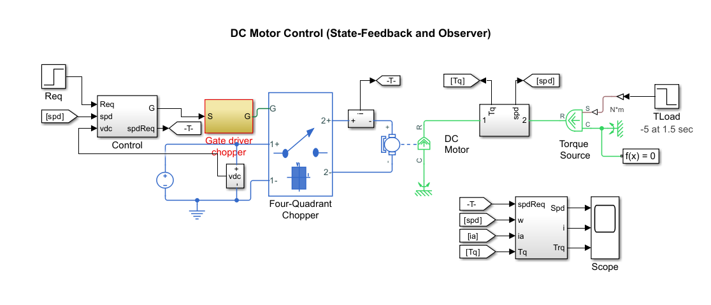

**Matlab Code**

**%% Parameters for DC Motor Control Example (State-Feedback and Observer)**

**%% DC Motor Parameters**

**Ra=4.4; %[Ohm]**

**La=41.2e-3; %[H]**

**Bm=0.005; %[N*m/(rad/s)]**

**Jm=0.009; %[Kg*m^2]**

**Kb=1.085; %[V/(rad/s)]**

**Kt=1.26;**

**%% Control Parameters**

**Ts = 5e-5; % Fundamental sample time [s]**

**fsw = 1000; % Switching frequency [Hz]**

**Tsc = 1/fsw; % Control sample time [s]**

**deadTime = 5; % Sensor delay in control samples**

**eig = [0.3,0.3,0.2].*exp(1i*[pi/6,-pi/6,0]); % Desired eigenvalues**

**va_max = 220; % Maximum armature voltage [V]**

**ia_max = 12; % Maximum armature current [A]**

**ia_min = 0; % Minimum armature current [A]**

**%% Continuous state-space model**

**A=[-Bm/Jm Kt/Jm; -Kb/La -Ra/La ]**

**B=[0; 1/La]**

**C=[1 0]**

**D=[0];**

**Output Waveform**

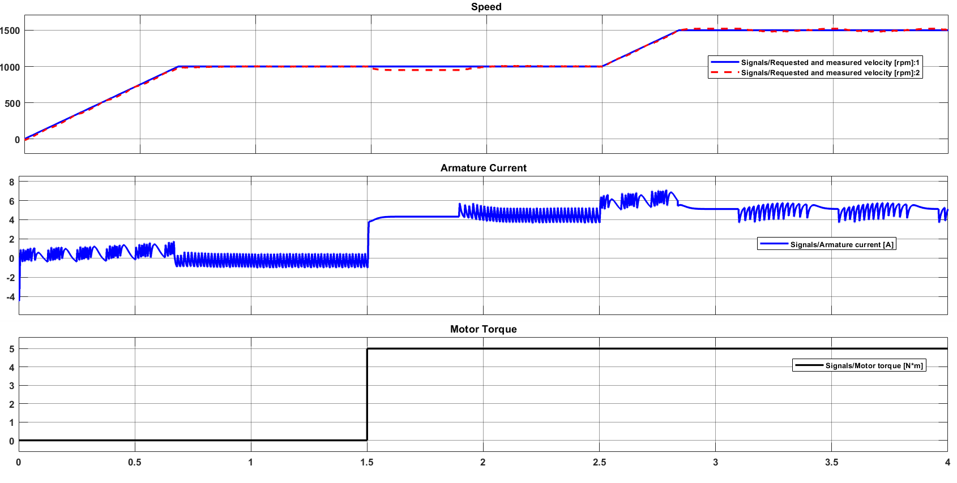

**Result**

Thus, the controllability and observability test in simulation platform is performed and verified.